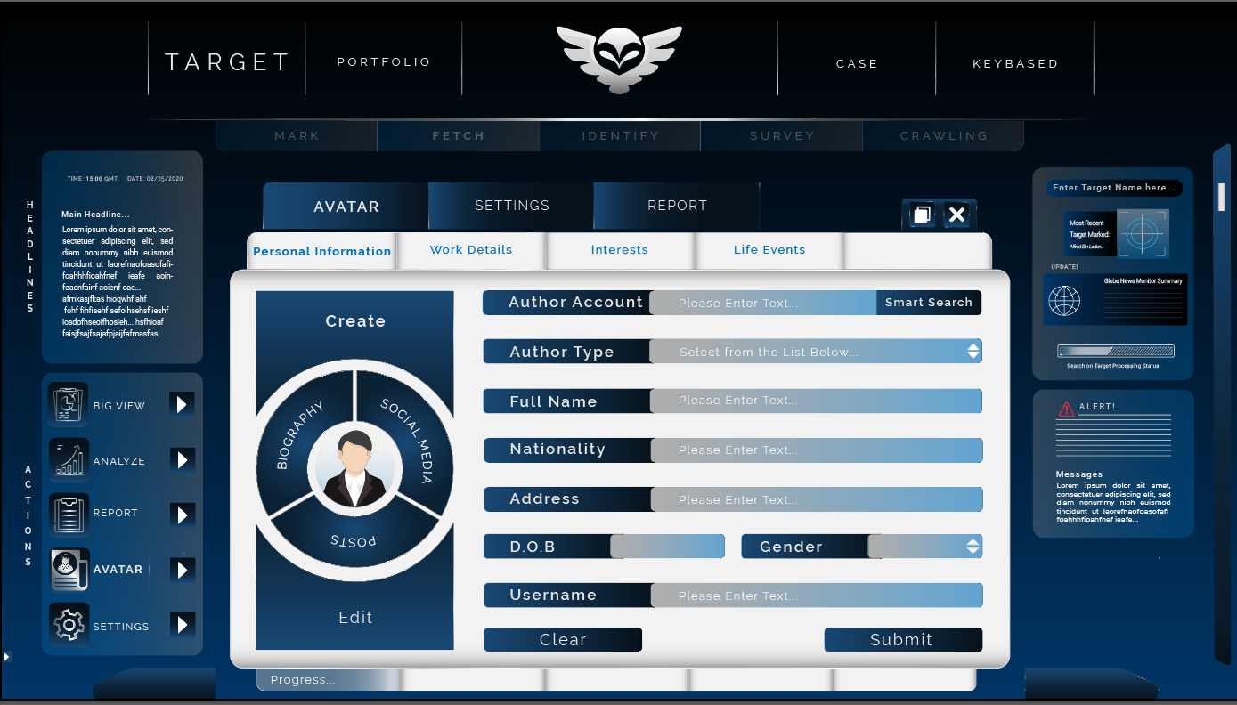

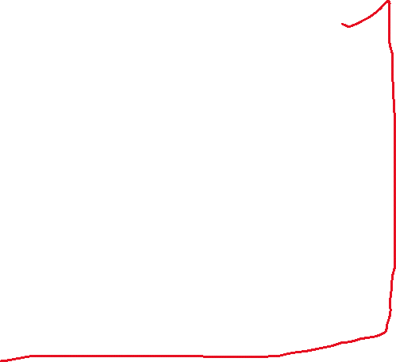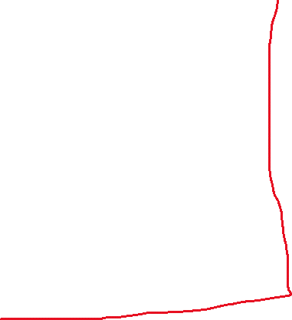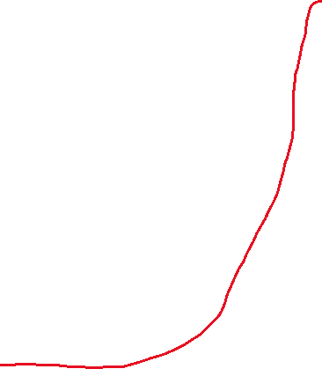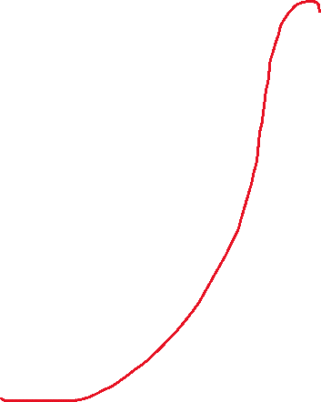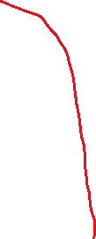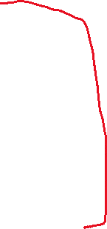

* Roboto regular 8.52px

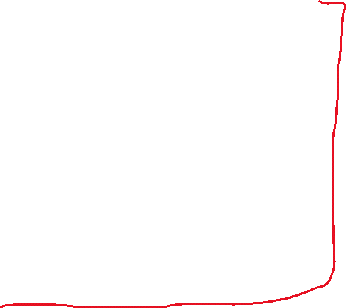

* Roboto medium 12px

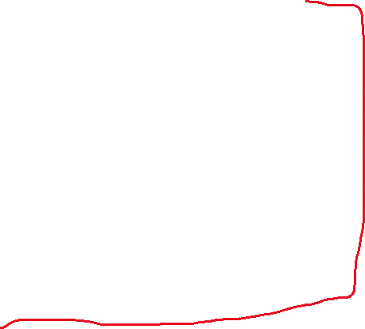

* Roboto regular 11.86px

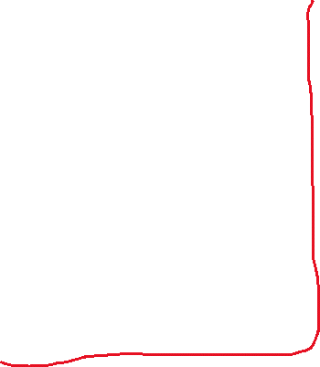

* Raleway bold 14px
* Raleway regular 15.67px



* Raleway bold 18px
* Roboto medium 13.86px
* Roboto light10.42px
* Roboto regular 9px
* Roboto light 9.02px
* Roboto light 8.25px
* Roboto regular 13.1px
* Roboto medium12.12px
* Roboto regular 10.07px